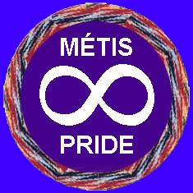
Kespu’kwitk Métis Council

Mailing & Office Address: Phone: 902-742-6591
368 Main Street Email: kmcmetis@gmail.com
Lovitt Plaza, Suite 221 Facebook: Kespu’kwitk Metis Council
Yarmouth, NS B5A 1E9 Website: www.kmcmetis.ca

CARD RENEWAL
Applicant’s Information:

Surname: ___________________Maiden Name (if applicable) _____________________

First & Middle Names ______________________________________________________

Mailing Address: ___________________________________________________________

Town/City: ____________________ Province _________ Postal Code: ______________

Date of Birth: ________ / ___________ / ____________
Day Month Year

Telephone Home: _______________________ Work or Cell: ________________________

Email: _____________________________________________________________________

____________________________________
APPLICANT’S SIGNATURE

___________ / ___________ / _____________
Day Month Year

Please include a current “passport size” headshot photo with your application (good quality photos only). Photocopied ID cards are no longer accepted. THERE IS A FEE OF $40.00 (which includes $25 for current year’s dues and $15 for processing of new membership card.)

PLEASE RETURN THE COMPLETED FORM, PHOTO AND YOUR EXPIRED CARD TO:
Kespu’kwitk Metis Council, P.O. Box 424, Yarmouth, NS B5A 4B3
OR email the completed form, and a headshot photo taken from a mobile phone. Payment
may be made by cheque, cash or E-transfer at this email address.

KMC CARD NUMBER: _________________________

